LANCASHIRE PLACE NAME SURVEY

Newsletter

May 2014

Annual General Meeting
7th October 2014
at
Lancashire Archives

Most of the final details for this year’s AGM can now be confirmed and we hope very much that you will all be there.

Refreshments will be available in the Meeting Room at Lancashire Archives (Bow Lane, Preston) from 18:00 followed by the AGM at 18:30.

Subsequent to the AGM (say 19:00) there will be a talk by:
Dr. David Parsons
(University of Wales Centre for Advanced Welsh & Celtic Studies)

Those of you who attended the Centre for North West Studies day-school entitled:

Names and Voices: linguistic aspect of North-Western heritage

held at Lancaster University in October 2013 will recall the wonderful slides which indicated the sequence of linguistic influences via different coloured arrows arriving from various sources. (This is the first time I had really understood the sequence and the various impacts.)

The talk (the title to be announced later) will be open to all - not just members of the LPNS. The fee for the talk will be £5 (no reductions); tickets will be available in due course.

Attendance at the AGM is free.

Tithe Schedule Transcription
(and checking)

All tithe transcriptions have to be edited and checked before going onto LANCAT and this sometime enables us to spot interesting things.
This photograph shows part of the Goosnargh Map (DRB 1/86) - fields 613-617 & 619 are the ones that caused amusement for 613 & 614 are named as ‘Hornby Castle & Pit’ whilst 615, 617 & 619 have ‘Castle’ in their names.

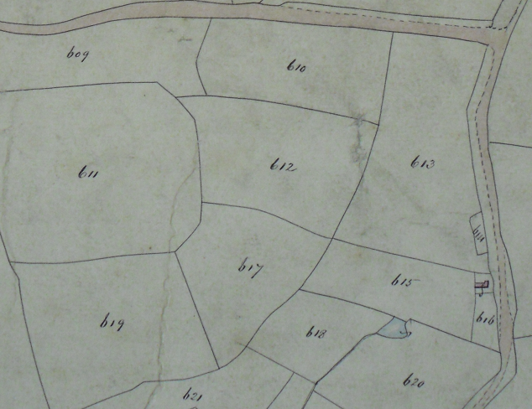
N.B. Walmsley Bridge Lane runs along the top and Winn House lies off the map to the south.
The real Hornby Castle lies north of Lancaster and there is no known link between the two townships.
However, the schedule shows the fields were owned by one Thomas Butler Cole who is described in the Victoria County History as ‘an eccentric man, died in 1864’. Whether the reference is actually to Hornby the place or to the prosperous Hornby family is unknown.

Society for Name Studies in Britain & Ireland
The Society’s latest newsletter is now available on line:
http://www.snsbi.org.uk/newsletter.html

