LANCASHIRE PLACE NAME SURVEY

Newsletter

September 2014

Annual General Meeting
7th October 2014
at
Lancashire Archives

All the details for this year’s AGM can now be confirmed and we hope very much that you will all be there.

Refreshments will be available in the Meeting Room at Lancashire Archives (Bow Lane, Preston) from 18:00 followed by the AGM at 18:30.

Subsequent to the AGM (19:00) there will be a talk by:
Dr. David Parsons
(University of Wales Centre for Advanced Welsh & Celtic Studies)

entitled

Lancashire and the Celtic Languages

The talk is open to all - not just members of the LPNS. The fee for the talk will be £5 (no reductions). Tickets can be ordered using the attached form

Attendance at the AGM is free.

Nominations for the Committee
As always, we are in need of nominations - you may recall that Jacquie Crosby was co-opted to replace Bruce Jackson who retired earlier this year. The treasurer is desperate to pass on her tasks - minuscule though they are. Nominations for committee members would also be enormously welcome. Again, the burdens of office are light - but we do like to share.

Foulridge Tithes DRB 1/81
Checking tithe schedules is not as tedious a job as you might imagine. The following entries are taken from the Foulridge tithe schedule. The owner was Ralph Brunskill who also lived there:

No. Occupants:
76 Ralph Brunskill Cottage
77 Ralph Brunskill Cottage
78 Peter Wilson Cottage
124{ Mark Hartley Cottage
124{ Rachel Knowles Cellar under cottage
132 Jonah Knowles Cottage
128a Bake House & Street for the use of Tenants

Presumably Rachel Knowles was living in the cellar - in which case, this could be a classic rural slum.

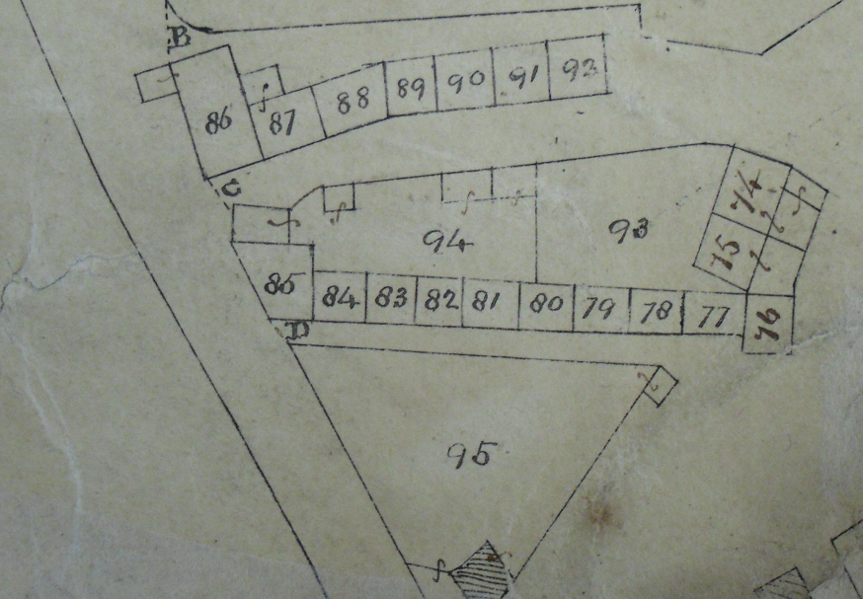

Unfortunately, it has so far proved impossible to work out just where these cottages were - but probably in Monkroyd or Burnside which are detached from the main area of Foulridge.

The Lancashire Place Name Survey

invites you to

Lancashire and the Celtic Languages

A talk to be given by

Dr. David Parsons
of
The University of Wales, Centre for Advanced Welsh & Celtic Studies

at
Lancashire Archives, Bow Lane, Preston, PR1 2RE

The talk will take place after the LPNS Annual General Meeting
on
Tuesday 7th October 2014 at 19:00

Tickets cost £5 each (no concessions) and must be paid for in advance.

Please note that due to the limited space available, there is a maximum number of 50 tickets available and these must be purchased in advance.

Name:
Address:

email address:

I would like to purchase _{insert no. required} ticket(s) for the talk by Dr. David Parsons after the Lancashire Place Name Survey Annual General Meeting at Lancashire Archives, Bow Lane, Preston, PR1 2RE on Tuesday 7th October 2014 at 19:00. Please send this order form, together with a cheque for the full amount due and payable to Lancashire Place Name Survey to:
LPNS, Jennifer Holt, 258 Blackburn Road, Haslingden, BB4 5JF.
All ticket orders must reach the LPNS by Monday 6th October 2014. N.B. Tickets will only be sent out (by second class post) where it is not possible to confirm the booking/ticket number(s) by email.

LANCASHIRE PLACENAME SURVEY
Nomination of Officer / Committee Member for 2014/5
Please bear in mind that membership is free; the only qualification for membership is an interest in the place names of Lancashire.

The election of Officers and Committee Members is to take place at the Annual General Meeting on 7th October 2014.

Name of Member being proposed :

Post for which they are proposed: (delete as appropriate)

Chair, Treasurer, Committee

……………………………………………………………………………..

Name of proposer:

Signature of proposed member indicating their willingness to stand:

Dated / / 2014
Members are welcome to nominate themselves.

